Name __________________________ Date __________________________

The Changing Roles of Minorities

Lillian Steichen Sandburg
- What makes Lillian important to history?

- Why do you think women were in political parties if they could not vote?

- If your classmates wanted to gain the right to vote in elections, what could you do to get started?

- Based on the passage, what does suffrage mean or refer to? Choose one of the following.
  - The right to surf
  - The right be in politics
  - The right to vote

Important Vocabulary Rating Scale
Place an “X” in the box to mark how well you know a vocabulary word at the beginning and at the end of the lesson.
Word | Definition | Don't Know | Familiar | Know it Well
Civil Rights | Rights of personal liberty. Guaranteed to U.S. citizens by the 13th and 14th amendments to the Constitution and by acts of Congress.
Suffrage | The right to vote in elections.
Discrimination | The unfair treatment of one person or a group of people
Ethnic | A group of people with the same culture, race, or nationality.
Minority | A group of individuals with the same gender, race, or ethnicity that make up less than half the population.
Role | The expected behavior for a person in a group.
Indigenous | The original people living in a region.
Change | To make or become different.
Enslaved | The condition of human slavery.
Civil War | The war between the United States of America and the Confederate states which attempted to secede from the U.S. to preserve the practice of chattel slavery. The war lasted April 12, 1861 - April 8, 1865, but the effects of the conflict lasted much longer.

Women as a Minority Over Time
- When was a woman’s right to vote protected by the U.S. Constitution?

- Who was the first woman to be Vice President?

Conditions of Enslaved People
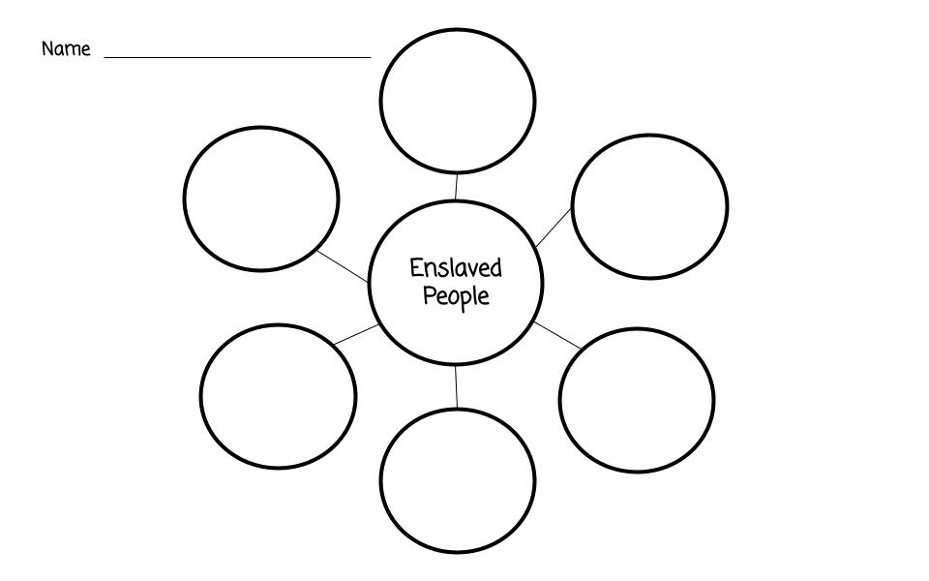
Fill out the Bubble Chart below with at least six conditions of life as an enslaved person. Feel free to add your own bubbles if you have more than six conditions.

African Americans as a Minority Group Over Time
- What was one group in North Carolina that discriminated against African Americans?

- What are two ways African American’s lives are different in the present than they have been in the past?

- What Act was supposed to end discrimination based on race, religion, or ethnicity?

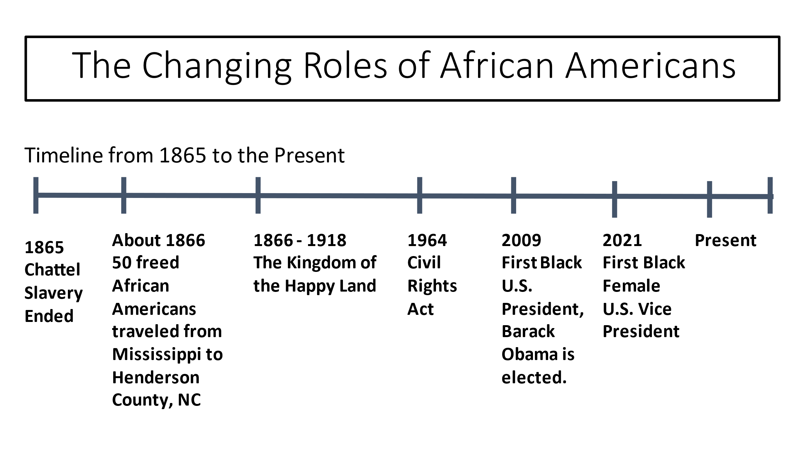
Timeline of the Changing Roles of African Americans

How Have the Roles of African Americans Changed Over Time?
Directions: Using at least 5 sentences, summarize how the role of African Americans, in the United States, has changed over time. Make sure to include examples.

  - 3 - 2 -1 Exit Ticket

Directions: Write three new words you have learned, list two minority groups we talked about, and record one role for minorities you would like to see changed or improved in your lifetime.

